Personal Time Survey¹
Chapman Learning Commons

Ever wondered, where does the time go? Categorized by activities, use this tool to find out. Try revising your schedule if you notice that you are spending too little or too much on a certain activity.

1. | Number of hours of sleep each night | ________ X 7 = _______
2. | Number of hygiene hours per day | ________ X 7 = _______
3. | Number of hours for meals/snacks per day (include preparation time). | ________ X 7 = _______
4a. | Total travel time weekdays | ________ X 5 = _______
4b. | Total travel time weekends | ________ X 2 = _______
5. | Number of hours per week for regularly scheduled functions (clubs, gym, get-togethers, etc.) | ____________________
6. | Number of hours per day for chores and errands | ________ X 7 = _______
7. | Number of hours of class per week | _______________
8. | Number of hours of work per week | _______________
9. | Number of average hours per week socializing, dates, etc. Be honest! | ___________________
 | Now add up the totals: | ___________________
 | Subtract the above number from 168 = | 168 − _______  = _______ hours left to study

Study Hours
In addition to class time, the average personal study time spent for one class each week is 6-9 hours. However, this time may vary depending on assignments and exams.

Adapted from: George Mason University, “Personal Time Survey,” Self-Development Center, (10 December 2004).

Visualize My Week

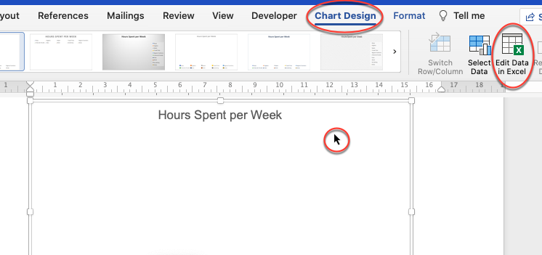
Click on the chart below select “Chart Design” “Edit Data in Excel.” Then input the hours you calculated above. The pie chart will then auto-populate!

